Schema Based File Entitlement import

* Introduction:  
  Saviynt EIC offers OOB capability to automated manual recon of entitlement through schema-based entitlement import.  
    
    
  How it works:  
    
  Saviynt has schema-based entitlement jobs which can be configured to automate recon of manual entitlement.  
    
    
  Prerequisites:   
    
  The Schema-based jobs require SAV and csv files for importing data, The sav files need to be present under the File directory in SAV files and csv files needs to be present in Datafiles. Ensure that the CSV file name must start with the string that you specified for the **FileNameStartswith**property.

Also Ensure that the SAV file name is suffixed with ENTITLEMENT_VALUES.

Integration Steps:  
1) Create a Sav file and put it in the sav folder under file directory (Accounts.sav)  
  
Sample SAV file for uploading accounts   
FILE_NAME_STARTS_WITH=Entitlement_Values_Import

SKIP_NO_OF_LINES=1

FILE_IMPORT_DELIMETER=,

EMAILTEMPLATE=SchemaFailureNotification

CREATE_SECURITYSYSTEM_IF_NOT_EXIST=YES

CREATE_ENDPOINT_IF_NOT_EXIST_IN_SECURITYSYSTEM=YES

CREATE_ENTITLEMENTTYPE_IF_NOT_EXIST_IN_ENDPOINT=YES

#ENTITLEMENT_VALUES_NOT_IN_FILE_ACTION=NOACTION

ENTITLEMENT_VALUES_NOT_IN_FILE_ACTION=INACTIVE

securitysystems,endpoints,entitlementtype,entitlement_value  
  
  
Lets understand the Sav file   
FILE_NAME_STARTS_WITH= Specify the string that you want to add as a prefix to the name of the corresponding CSV file.  
SKIP_NO_OF_LINES– Specify how many lines to skip in the file.

FILE_IMPORT_DELIMETER =   
Specify the character/delimeter to use to separate the data items in the file.

CREATE_ENTITLEMENT_VALUE1_IF_NOT_EXIST = Specify **Yes** if you want to create a new entitlement value for the parent entitlement.  
  
CREATE_ENDPOINT_IF_NOT_EXIST_IN_SECURITYSYSTEM =Specify yes if you want to create Endpoint  
  
ENTITLEMENTS_Values_NOT_IN_FILE_ACTION =   
Specify the action to take for the child entitlements that are not included in the CSV file but present in EIC:

The options are:

* **Delete:**Use this action to remove the existing child entitlements from EIC and upload the child entitlements from the CSV file.
* **No Action:**Use this action to retain the existing child entitlements in EIC and upload the child entitlements from the CSV file.

securitysystems,endpoints,entitlementtype,entitlement_value, customproperty1,status,soxcritical

The Csv file needs to have the column in the above order.

2) Once the Sav file has been created and put in the sav folder under files, Create the csv file in the format defined in the sav file.  
Sample csv file

securitysystems,endpoints,entitlementtype,entitlement_value,customproperty1,status,soxcritical

Amigopod,Amigopod,Access,IT Users,IT Engineers only,1,HIGH  
  
Here the first line defines the column so we have defined Skip_No_of_Lines = 1 in the sav file.  
  
  
  
3) Once both the files have been put in the respective folders. Head to Job control panel in EIC and create a new job under job type File based Entitlement import (Schema Entitlement) and schedule it. Specify the job type as Import Entitlement_Values

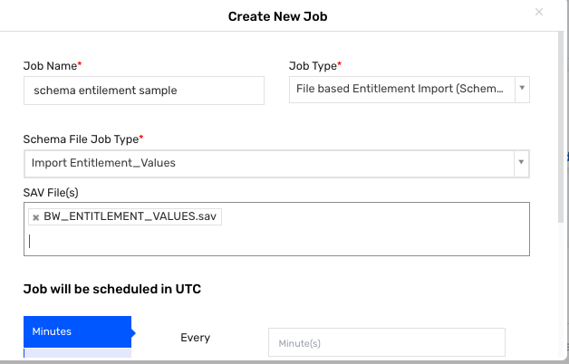

4) Once the job has been run successfully, the csv file will be archived and moved to success folder. If the job has failed for some reason, it will move to fail folder.  
  
  
  
**Troubleshooting**:  
  
The most common error in Schema Entitlement Error would be the File not found .  
  
  
Resolution  
Make sure that the latest csv files are present in the datafile folder and the sav files are present.